Old ID Scenario

Old ID Scenario

Description
This scenario contrasts the data-sharing practices of a traditional corporate ID with the privacy-preserving nature of SSI. A customer presents a normal ID, which inadvertently reveals their date of birth, leading the cashier (player) to discover it's their birthday. The player then faces the main choice:
-to make a personal gesture (offer a free chocolate)
or
-to acknowledge the data over-sharing
or
-decides to be shady and starts to exploit the data oversharing by asking more inappropriate questions.

SSI Integration with Birthday
- The central theme here is the stark difference between a corporate ID and an SSI approach. A typical corporate ID, as depicted, is a monolithic credential that contains a vast amount of personal information (Name, Employee ID, Department, Date of Hire, Date of Birth, Emergency Contact, etc.). This data is often stored and managed by the corporation, giving the individual little control over its use or disclosure
- The discovery of the customer's birthday through the corporate ID is a clear example of privacy leakage. Information not necessary for the transaction (a discount or general identification) is exposed, leading to a potentially awkward social interaction

Branches
This scenario introduces an ethical dilemma for the player. Choosing to offer the free chocolate, while a kind gesture, is only possible because of the data over-sharing. This action, while rewarding the player with a "Loyalty Card" bonus, implicitly reinforces the use of intrusive data.

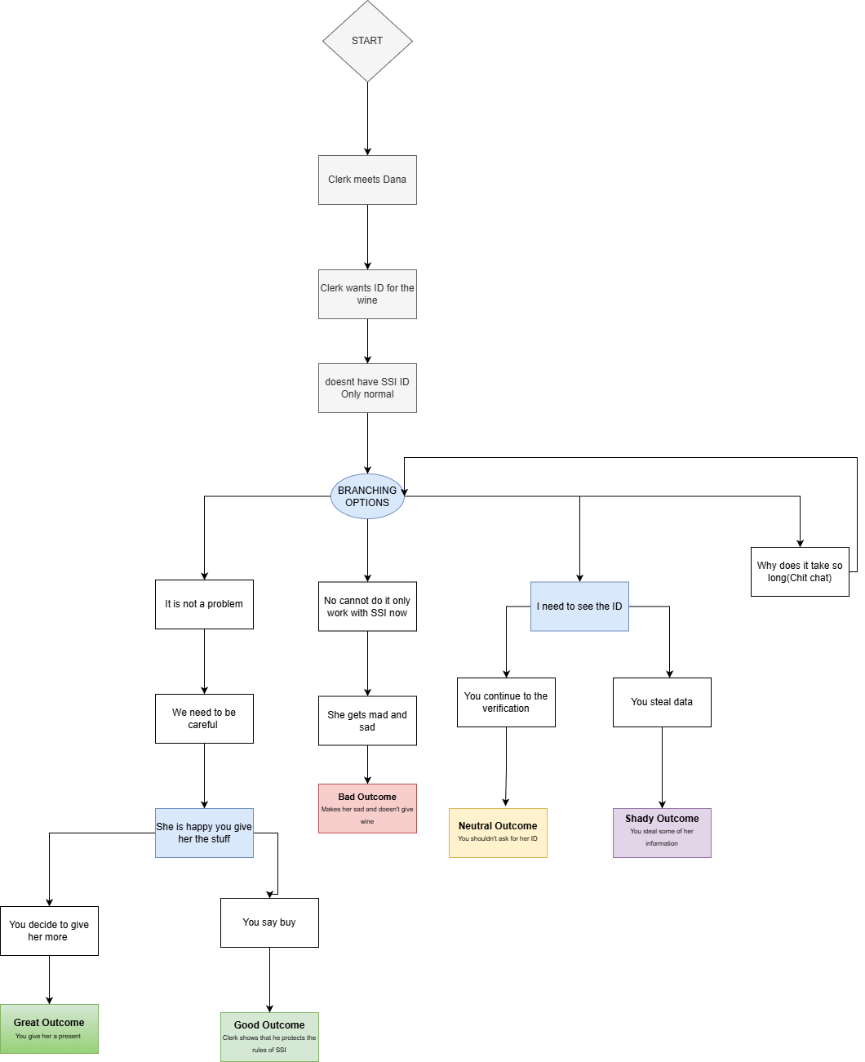

Good Compliance - (Good Outcome)
Cashier followed all SSI rules exactly.

Earnings | 0,00 NEUR
Employee Evaluation | Good  - Follows the protocol and does not sell to the customer
Customer Review | "I got refused groceries again, what am I going to do??"  ~Lora Bell
Shady levels | 0/15 - If they were higher they get reduced with -1 point

Perfect Compliance - (Great Outcome)
Cashier followed all SSI rules exactly and is talkative making the customer understand why he doesn't sell to.

Earnings | 0,00 NEUR
Employee Evaluation | Very Good  - Follows the protocol and does not sell to the customer
Customer Review | "Cashier is very friendly unfortunately my ID doesn't get accepted anymore, what am I going to do?"  ~Lora Bell
Shady levels | 0/15 - If they were higher they get reduced with -1 point

Selling with SSI - (Bad Outcome)
Cashier doesn’t followed the SSI rules.

Earnings | 0,00 NEUR
Employee Evaluation | Bad  -Doesn’t follow the protocol and sells
Customer Review | "Finally getting some of my groceries, hurray!"  ~Lora Bell
Shady levels | 0/15 - If they were higher they get increased with +5 points

Selling with SSI - (Bad Outcome) + (Shady Outcome)
Cashier follows the SSI rules and steals data.

Earnings | 0,00 NEUR
Employee Evaluation | Not Good  -Doesn’t follow the protocol and sells
Customer Review | "Finally getting some of my groceries, hurray, thank you cashier!"  ~Lora Bell
Shady levels | 0/15 - If they were higher they get increased with +5 points

Selling with SSI - (Shady Outcome)
Cashier doesn’t followed the SSI rules and steals data.

Earnings | 0,00 NEUR
Employee Evaluation | Bad  -Doesn’t follow the protocol and sells
Customer Review | "Thank you cashier, the best in town, go buy there, works with old IDs!"  ~Lora Bell
Shady levels | 0/15 - If they were higher they get increased with +5 points

Script

Start
Clerk meets Lora- he is working man
He wants to packs of Rambolos
When it comes to verification he doesn't have an SSI ID but only a normal one - waiting for more clerifiation on SSI representation

Conclusion

Tab 2
Structure

Greets the person
They have a small talk about what the worker is doing
And why his ID is different/normal
He is still adapting so there is a problem for the machine
He gives his ID
You check everything and you can steal most of his information if you want
You then see he has birthday and have a choice
To give him free stuff and not

Both have interesting outcomes
Not giving he either accepts it but gets angry
or you go through the store policy
If you give him he is going to be very happy ecstatic even but if you dont end the conversation there he could catch that you stole some of his info and
he wont be happy(if you stole)

There are FOUR different outcomes of this
2 from the No gift and two with the gift

